# PyQt

## Development environment

1. Hardware environment
   1. PC

In the development of Demo, Window7 64-bit operating system is used on the PC.

* 1. Qualcomm 410c development board

Qualcomm 410c development board with Debian system, its kernel is linux kernel.

1. Software Environment

2.1 Python3

Python3 development language is used in software development. The Python version used is Python 3.4.2.

2.2 PyQt4 & Qt designer

PyQt is a toolkit for creating GUI applications that incorporates the Python language and the Qt library. Implements a Python module set. It has over 300 categories and nearly 6,000 functions and methods. Can run on all major operating systems including UNIX, Windows and Mac.

2.3 PyCharm

On the PC, use PyCharm software as a Python scripting tool for PyQt.

PyCharm is a Python IDE with a full set of tools to help users improve their productivity when using the Python language, such as debugging, syntax highlighting, Project management, code jumps, smart hints, auto completion, unit testing, version control .

1. Reference materials

Python：<https://www.python.org/>

PyQt：<https://doc.qt.io/archives/qt-4.8/index.html>

## PC Development Environmental configuration

1. Python3 download and install

First download the Python 3.4.2 version of the Window7 64-bit installation package from Python's official website, the specific download link is <https://www.python.org/downloads/release/python-342/>

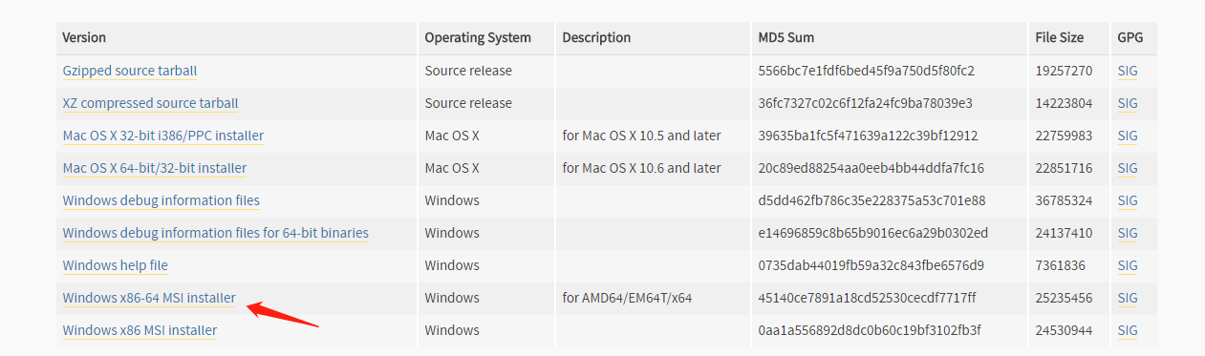

After the Python3.4.2 installation package is downloaded, double-click the package and follow the prompts to install. The default installation path is C:\Python34.

At this point, the PC-side window7 64-bit Python 3.4.2 development environment has been configured.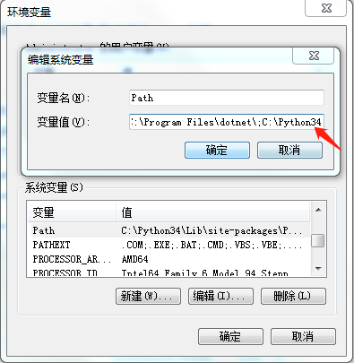

To verify Python 3.4.2 is installed successfully, you can use the CMD command: Start -> Run -> type cmd or command, enter Python, as shown in the following figure is Python3.4.2 environment configuration is successful.

On the development board of Qualcomm 410c, Debian system system has built-in development environment of Python2 and Python3. Open the terminal and input Python3. You can see the code similar to the above figure appears, that is, Python3 is installed.

1. PyQt4 download and install

In the PC's Window7 64-bit environment, PyQt uses version 4.11. This version of the exe installation file can be downloaded from the link [https://sourceforge.net/projects/pyqt/files/PyQt4/PyQt-4.11/](https://sourceforge.net/projects/pyqt/files/PyQt4/PyQt-4.11/.在PC的Window64位的环境中使用了PyQt4.11版本，从链接（https:/sourceforge.net/projects/pyqt/files/PyQt4/PyQt-4.11/）中可以下载该版本的exe安装文件。)

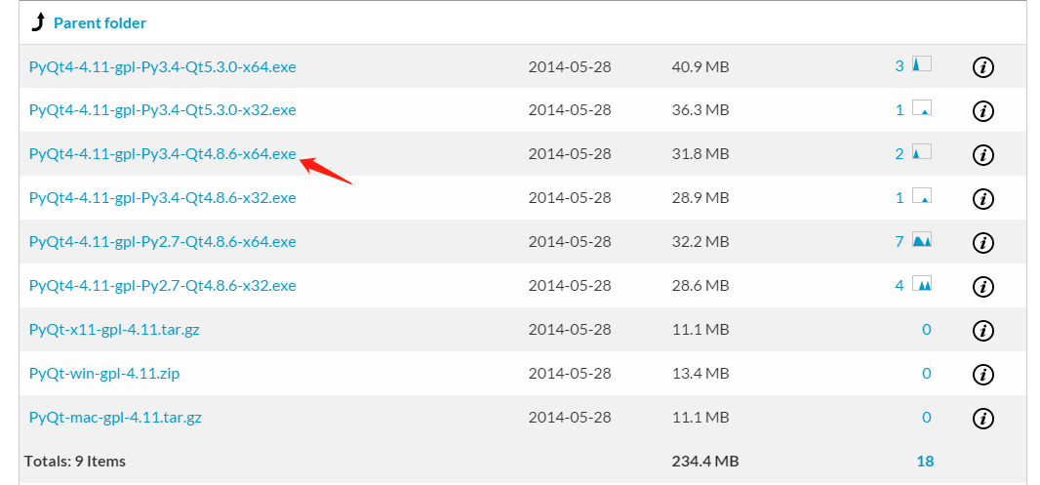After the installation file is downloaded successfully, double-click it to install it. The installation path is the default path. After the installation is successful, you can find the PyQt4 related files in the path of C:\Python34\Lib\site-packages\PyQt4.

In this path, the designer.exe file is the Qt GUI design software, and the user can design the UI style of the GUI software in the software.

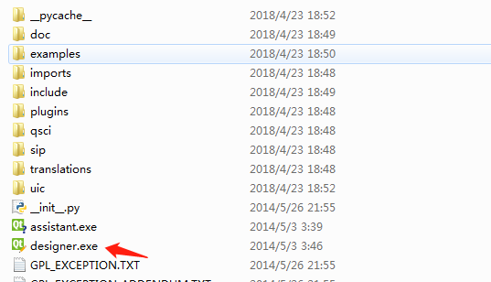

At this point, the PyQt4 environment on the Windows 7 64-bit PC has been configured.

1. PyCharm download and install

First, download the installation package from PyCharm official website. The official website link is https://www.jetbrains.com/pycharm/. The version selected here is pycharm-community-2018.1.1. After the download is successful, install it.

Next configure QtDesigner, open Pycharm, select File->Settings, select Tools->External Tools in the pop-up panel, click the Add button to edit the information as follows:

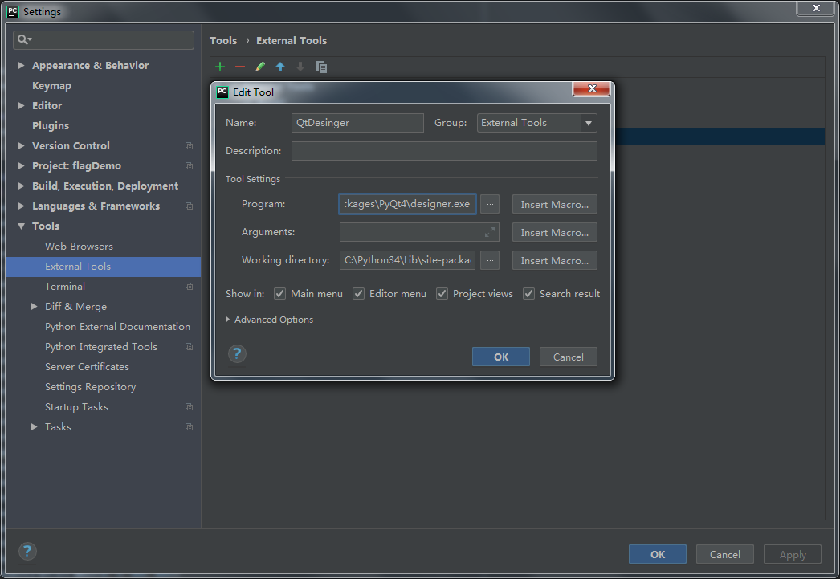The Name tag is set to QtDesigner, Program is the designer.exe file in the PyQt4 installation directory, and the Working Directory is PyQt4's installation directory. Click OK to add it successfully.

Configure PyUIC, also click the Add button, the configuration information is as follows:

Name is set to PyUIC, Program is a Python file in the Python installation directory, Arguments is set to -m PyQt4.uic.pyuic $FileName$ -o $FileNameWithoutExtension$.py, Working Directory is $FileDir$, click OK to add success.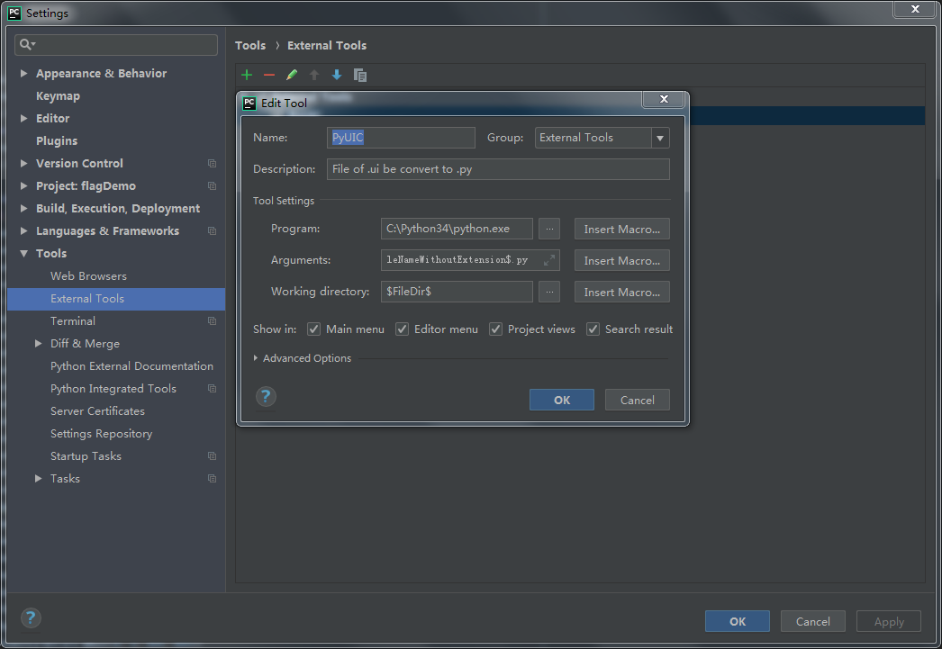

Configure PYRCC and the configuration information is as follows: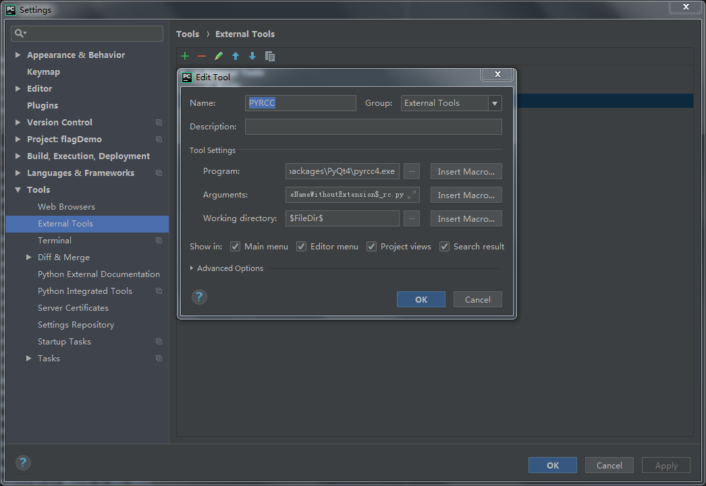

Name is set to PYRCC, Program is the pyrcc4.exe file in the PyQt4 installation directory, Arguments is set to -py3 $FileName$ -o $FileNameWithoutExtension$_rc.py, Working Directory is $FileDir$, click OK to add it successfully.

The final environment configuration information is as follows:

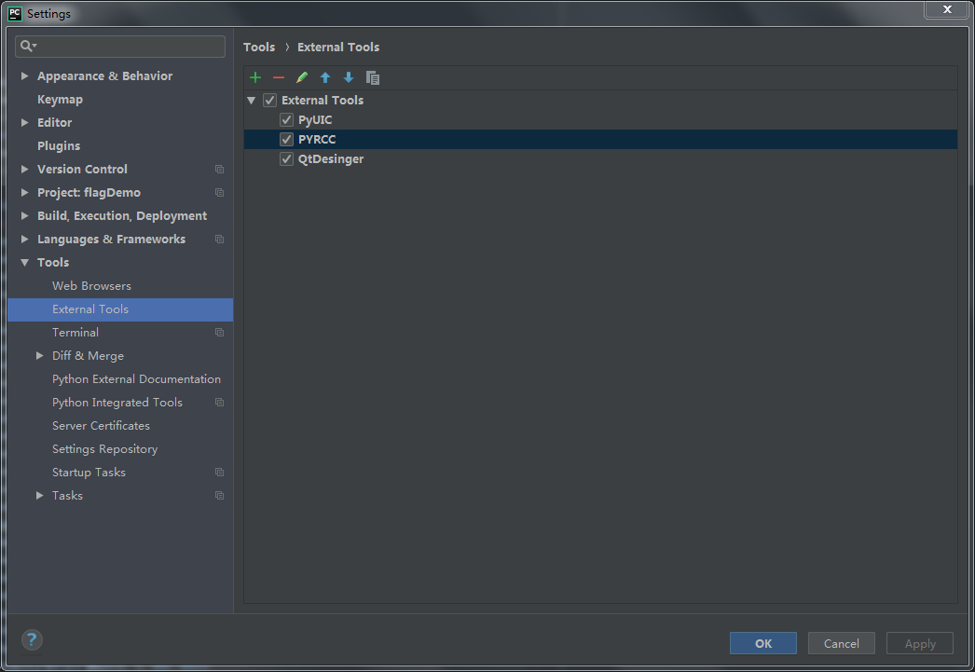

## Qualcomm 410c operating environment

1. Update system

Open the terminal, enter sudo apt-get update and press Enter Key

1. Pip download and install

Open the terminal, enter sudo apt-get install python3-pip. If you see the following prompt:

ble to fetch some archives, maybe run apt-get update or try with --fix-missing

Please enter sudo apt-get update and reenter sudo apt-get install python3-pip

1. PyQt4 download and install

Open the terminal and entersudo apt-get install python3-pyqt4 to install PyQt4 until

the installation success flag appears.